[Stir-Fried Shrimp with Celery](http://en.christinesrecipes.com/2008/12/stir-fried-shrimp-with-celery.html)

[http://asset1.ziplist.com/wk/add_recipe-small.png](http://www.ziplist.com/webkitchen/button/add_recipe?as_partner=christinesrecipes)10

Apart from the cleaning and trimming job, shrimps are easy to cook. Having said that, I love eating shrimps. This dish, [Stir-Fried Shrimp with Celery](http://www.christinesrecipes.com/2008/10/stir-fried-shrimp-with-celery.html), was done weeks ago, yet I couldn’t manage to translate the recipe until now. We can use any kind of shrimps to stir-fry with any kind of vegetables. Sounds flexible! Yeah, Chinese stir-fry dish is very flexible. It’s all up to your choices and favorites. This time I used tiger prawns. (Here in Australia, we commonly use “prawns” instead of “shrimps”.)

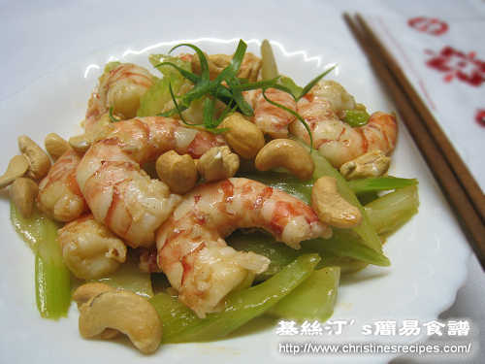

[http://2.bp.blogspot.com/-UFGgQJJjWFE/URxCpiZXFrI/AAAAAAAALjo/VNHLIdiqv80/s1600/pinterestx1_60.png](http://pinterest.com/pin/create/button/?url=http://en.christinesrecipes.com/2008/12/stir-fried-shrimp-with-celery.html&media=http://lh4.ggpht.com/christinehoau/SPCTfENLT4I/AAAAAAAADJs/U9UMbihrOJY/s800/%E8%A5%BF%E8%8A%B9%E7%82%92%E8%9D%A6%E4%BB%81%20Stir-Fried%20Shrimp%20with%20Celery.jpg&description=Stir-Fried%20Shrimp%20with%20Celery%20from%20Christine%E2%80%99s%20Recipes)

**Ingredients:**

* 3 stalks celery, about 150 gm
* 190 gm shrimp (prawn, fresh or frozen), medium size
* 1 tsp minced garlic
* 1 tsp Shaoxing wine
* 3 Tbsp unsalted chicken broth
* 20 roasted cashews, unsalted
* 2 tsp egg white, lightly beaten
* Salt and white pepper, to taste (for marinating shrimp)
* salt and cornflour (for rinsing shrimp)



**Thickening:**

* 1 tsp light soy sauce
* 1/2 tsp sugar
* 1/2 tsp corn flour
* 1 Tbsp water
* white pepper, to taste
* a dash of sesame oil

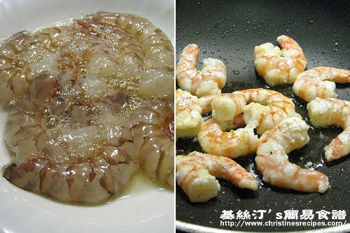

**Method:**

1. Defrost the shrimp if frozen and peel the shell. Devein the shrimp. Mix shrimp with a bit of salt and cornflour, and leave for a few minutes. Rinse thoroughly with cold running water. Drain well and Pat dry the shrimp with paper towels. Marinate the shrimp with a bit of salt, white pepper, egg white and corn flour for 20 minutes.
2. Rinse celery and cut into strips. Set aside.
3. Add cooking oil to wok, sauté shrimp on medium heat until 80% cooked. Dish up and set aside.
4. Add 2 tablespoons of oil to sauté minced garlic. When you smell the aroma of the garlic, add celery. Sprinkle with wine and a pinch of salt. Quickly stir well. Add chicken stock to cook for a while, uncovered. Toss shrimps back to wok and cook, add thickening. When sauce begins to dry up, add roasted cashews. Dish up and serve on a platter. Enjoy!

Tip:

You can get ready-made roasted cashews at supermarkets or do it by yourself. Bake raw cashews for about 10 minutes or until lightly brown in a preheated oven at 180C.

Read more: <http://en.christinesrecipes.com/2008/12/stir-fried-shrimp-with-celery.html#ixzz36E5WkZkO>